### **Team details**

| **Team Name** | Slytherin |
| --- | --- |
| **University** | University of Kelaniya |
| **Domain** | Education Domain |
| **Product Name** | AI-Powered Grading Assistance |

### **Problem Statement, Background & Motivation and Solution**

**Problem Statement:**

* Learning management systems (LMS) can automate the marking of multiple-choice questions (MCQs), which helps streamline the grading process for assessments.
* However, LMSs currently **lack automation for evaluating written answers**, This means that teachers or lecturers **have to spend a significant amount of time evaluating exam papers manually.**

**Background & Motivation:**

* There are some tools to automate this marking process but they just use cosine similarity to do it. This method does not produce promising results because it can’t understand semantic meaning of a sentence
* This manual process of paper evaluation adds to the workload of lecturers, especially in university systems in Sri Lanka.
* The shortage of lecturers in Sri Lankan universities exacerbates the issue, as each lecturer has a heavy workload for tasks like exam marking (including mid-term exams, end-of-term exams, and spot tests).

**Solution:**

* Introduce a combination of RAG and Classification model to automate the marking process in educational assessments.
* The lecturer uploads the marking scheme and the student's written answers to the model (pdf or text).
* The AI model **analyze each question and its related answer, generating appropriate marks** and feedback for each question.
* Feedback includes the allocated mark for the question and an explanation of why the student received that particular mark.
* For example, if a student receives a lower mark, the model provides feedback explaining why that mark was given for that question. Similarly, if a student scores well, the model offers feedback on why they received a higher mark.

### **Product Description and Product Uniqueness**

**Product Description:**

* The proposed solution involves four components to automate the marking process for educational assessments.
* The **first component** is an Optical Character Recognition (OCR) model. It scans through the PDF documents containing students' written answers, identifies the text on each page, and converts it into editable text.
* Then groups each answer along with its corresponding marking and creates a dictionary. This dictionary contains the question-answer pairs along with the assigned marks.
* The **second component** is a **Classification and RAG model**. It takes the dictionary containing question-answer pairs and marks as input. Using this information generates marks and feedback for each question. The feedback includes explanations for why a particular mark was assigned to each question.
* 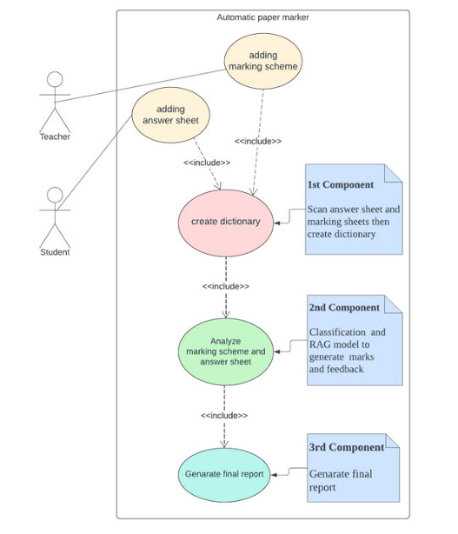Finally, the **third component** receives the feedback along with the questions and generates a report. This report likely summarizes the marks assigned to each question, along with the associated feedback, providing insights into the student’s performance in the assessment.

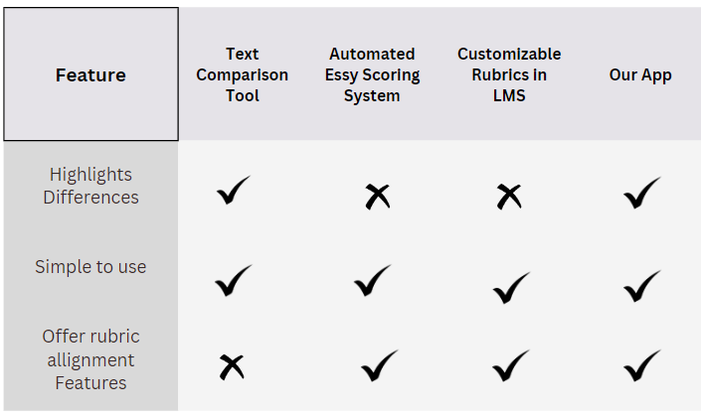**Product Uniqueness:**

**Business Model and Marketing Plan**

**Business Model:**

* We plan to introduce a **subscription model** with **three main categories: Institutional Package, Students, and Teachers.**
* The **Institutional Package** targets educational institutions such as universities, colleges, and schools, offering an LMS with institutional extensions.
* This package includes a limited number of user accounts tailored to the institution's needs.
* The **Student and Teacher categories** provide personal accounts for individual use.
* Each user receives their own version of the product for personal use.
* All three categories (Institutional Package, Students, Teachers) offer three different tiers: Standard, Pro, and Pro Max, catering to varying needs and preferences.

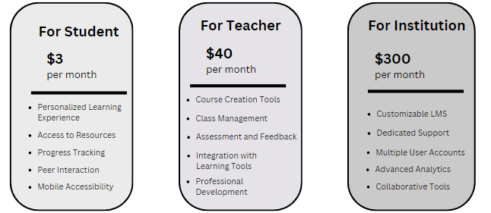

**Marketing Plan:**

* In the Sri Lankan higher education system’s Learning Management Systems (LMS), there is no tool to automate the marking of essay questions. While LMSs can automate the marking of Multiple-Choice Questions (MCQs), they fall short when it comes to essay questions, thereby creating a significant local market gap.
* Upon examining university LMSs worldwide, we find a similar lack of proper tools to automate this process. This gap presents an opportunity for the development of a tool that could be used by students individually to understand why they received a low mark compared to an answer. Additionally, individual teachers could use this tool to mark papers, thereby streamlining the grading process.
* According to Google, there are over 25,000 universities, 7 million schools, 93.7 million teachers, and 235 million students around the world. This data underscores the vast global market potential for such a tool.
* Our proposed solution aims to fill this gap, providing an automated essay grading tool that caters to the needs of students, teachers, and educational institutions worldwide.

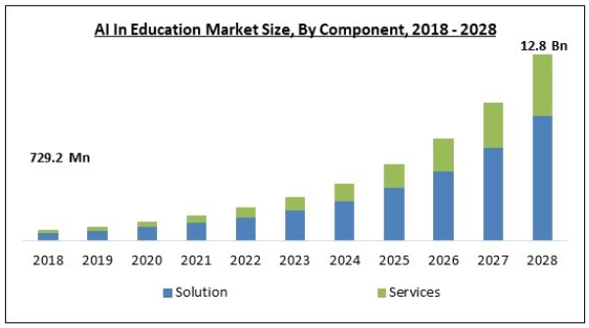

**Technical Aspects and Implementation Plan**

**Technical Aspects:**

* **APIs**
  + **Google Vision API**: In order to identify handwritten answers written by students we have used google vision API.
* **Frameworks**
  + **LangChain**: To build our RAG model we have used langchain as a framework.
  + **Pytorch**: Our classification model is entirely built using pytorch.
  + **React**: We have used react to build user friendly interface.
* **Platform**
  + **Comet ML**: Comet ML is used to generate reports of our models and to store performance metrics of our models.
  + **Hugging Face**: We used Hugging Face to import free and open-source large language models to build our RAG model.
* **Others**
  + **Node**: We have used node as our backend technology.

**Implementation Plan:**

* Project Planning and Requirements
  + Define scope, objectives, and gather stakeholder requirements.
  + Outline features and functionalities.
* System Design and Data Preparation
  + Design architecture (front-end, back-end, AI components) and choose technologies.
  + Collect and preprocess data, perform EDA, and feature engineering.
* Model Development and Evaluation
  + Develop and train AI model, optimize performance, and evaluate using metrics like accuracy, precision, and recall.
* Integration and User Interface
  + Develop front-end and back-end, integrate AI model, and design user-friendly interfaces.
* Deployment, Testing, and Maintenance
  + Deploy to production, ensure scalability and reliability, conduct comprehensive testing, monitor performance, and update AI model regularly.
  + Document processes and generate performance reports.

### 

### **User Scenario**

* We mainly provide 3 options to users they are **pdfs grading, image grading and text grading.**
* Let’s talk about them separately but first let’s go through user interface.
* **User Interface & Options**

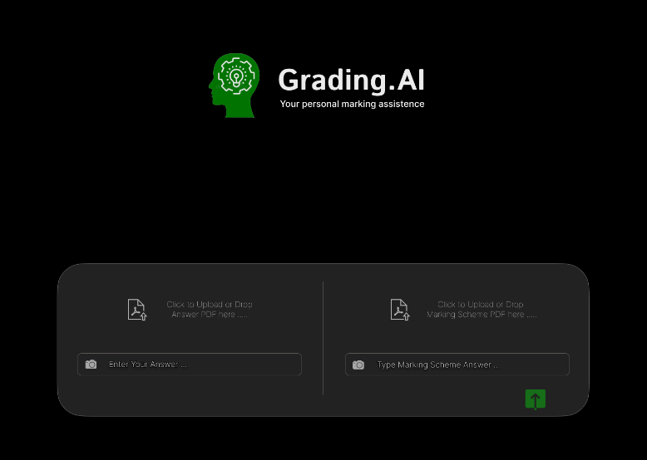

* Customer uploads answers (PDF, image, text).
* Enter real answer in matching format. .If the answers are in pdf format the marking scheme or the real answer must be also in pdf format the same principle is applied to both text and images.
* Submit to receive grading and feedback based on uploaded answers.
* **PDF Grading**

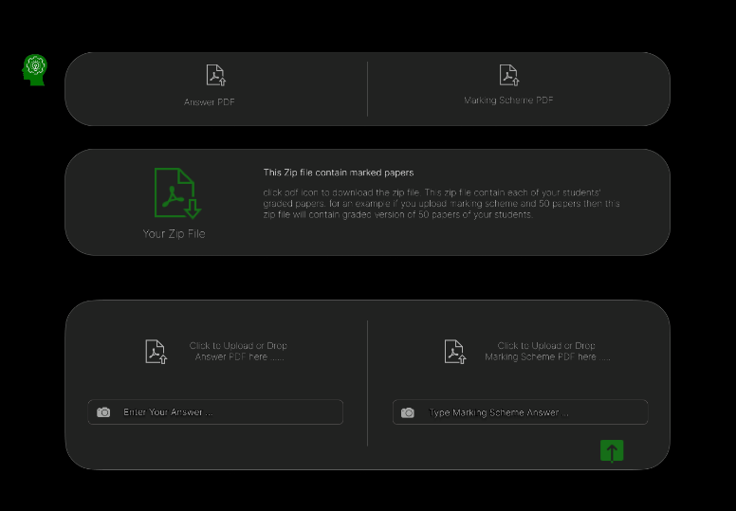

* + The lecturer can upload all of his/her students’ papers to the right-hand side of the chat box as mentioned previously. Then he/she must upload the marking scheme to the right-hand side of the chat box. Then click the submit button.
* It will generate report for each student and create a zip file. For an example if you upload 50 student papers then you will get 50 reports for each student these reports are also in pdf format and they contain marks and feedback for each individual answers written by students.
* The lecturer can download the zip and can inspect the marks. Also, if she/he want they can distribute this soft copy among students so the students can identify their weakness.
* This method save time. Also, this method provide chance for undergraduates to know their mistakes and correct them while protecting confidentiality of original papers which is maintain by lots of universities.

**Note - To use this feature the papers must be printed according to special format.**

* **Image Grading**

### 

* Here user can take picture of answer and marking then add them to chat box.
* According to the previously mentioned method grading process will happen.
* Text grading will take similar approach to image grading instead of images user can type student answer and real answer. Hence, we are not going to describe it.

### **Team Details**

Wickramarathna.

200130802907

[wickram-cs20035@stu.kln.ac.lk](mailto:wickram-cs20035@stu.kln.ac.lk)

071 992 5363

HMBS Induwara

200135201072

bhasithag@gmail.com

070 288 2517

KRD Kahena

200162702006

Kahenak-cs20058@stu.kln.ac.lk

070 197 0451